Patterns in the Cascade Range

How can you use the history of Mount Rainier's eruptions to decide whether hiking around Mount Rainier is safe?

In this activity, you will take a closer look at the pattern of eruptions on Mount Rainier and surrounding volcanoes to see what this might tell you about future eruptions.

Mount Rainier is part of a mountain range called the Cascades, which includes many volcanoes. Located in the Pacific Northwest, the Cascades extend from northern California, United States, to southern British Columbia, Canada.

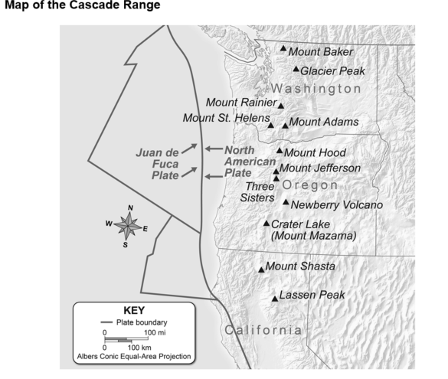

**Analyze and Interpret Data**

Part A: Mount Rainier and the Cascade Volcanoes

1. **Analyze Data** Analyze *Map of the Cascade Range*. What observations can you make about the locations of the volcanoes, both in relation to each other and to the plate boundaries shown? I notice there are many volcanoes and eruptions that have occurred and based on the details it's likely that the plates could start moving again and a volcano could erupt.
2. **Determine Similarities** Scientists studying Mount Rainier are very interested in the volcanic history of all the Cascade volcanoes. Why do you think scientists studying Mount Rainier also study other volcanoes in this range? I think they study it to know more about volcanoes and to make sure people can be in this area.

Part B: History of Eruptions in the Cascade Range

Volcanoes in the Cascade Range have been erupting for over 500,000 years. The timeline in the pictograph shows eruptions of several Cascade volcanoes over the past 4,000 years. Each volcano symbol represents an *eruptive period,* or a time when one or more eruptions occurred over a few days, months, or years. Use the timeline in the pictograph to answer the questions below.

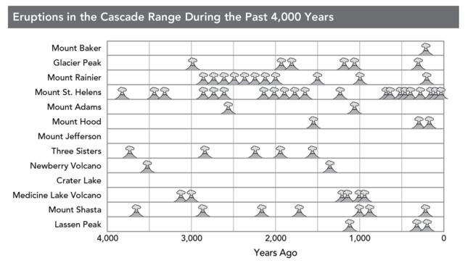

1. **Use Models** Look at the pictograph. What do you notice about the pattern of eruptions at Mount Shasta? It has occurred 4,000 years, 3,000 years, 2,000 years, 1,000 years, and 0 years ago.
2. **Identify Patterns**Is there a pattern of eruptions for Mount Rainier? If so, how would you describe the pattern? If there was a pattern for Mount Rainier it would erupt a lot every 2,000 years a lot.
3. **Compare Data**Compare the pattern of eruptions of Mount St. Helens to the eruptions of Mount Rainier. In the modern century Mount St Helens has erupted more now than in the past and Mount Rainier in the past more eruptions have happened than in the present.
4. **Interpret Data** Which volcanoes have had a period of 1,000 years without an eruption? Did any of these volcanoes erupt again after 1,000 years? At Mount baker it has only erupted 1 time in the present. All volcanoes except Mount Baker have erupted and had more than a period without 1,000 years of erupting.
5. **Predict**The last time Mount Rainier had a significant eruption was approximately 1,000 years ago. Analyze and interpret data on the past eruptions of Mount Rainier to forecast whether Mount Rainier will erupt catastrophically again. Explain your answer based on the data in the pictograph. Also consider your answers to the previous questions. Over the years Mount Rainier has erupted many times. I think it will not erupt for a few thousand years because in the beginning it didn’t do that many eruptions and then there were so many eruptions. I think it will stay dormant for a few thousand years.
6. **Apply Concepts**How does your answer to the previous question affect your thinking that hiking around Mount Rainier is safe? After reading the graphs I think Mount Rainier is not safe thanks to so many eruptions happening because of it.
7. **Ask Questions**What other questions would you want to ask before making a final decision about whether hiking around Mount Rainier is safe? I would like to ask if it is really a good idea to walk in an area with volcanoes that could erupt at any time and kill you. Plus on top of Mount Rainier there are more volcanoes that can erupt. And if you want to see a volcano erupt you need to have the most protective place to watch it instead of just walking around.